**Why Wanza Jeans Is the Ultimate Destination for Men's Jeans for Retailers and men's jeans for brands**

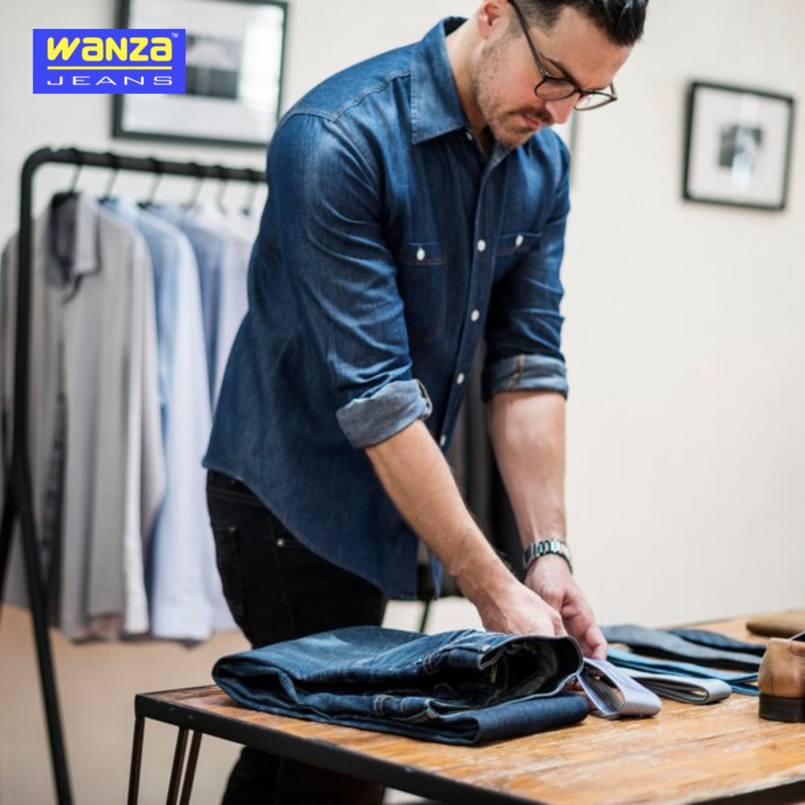

**High fidelity men- jeans customized to retailers**

**Wanza Jeans** has earned a strong reputation for delivering premium [**men's jeans for retailers**](https://wanzajeans.com/) across the globe. The retailers require the products that are not only attractive to the consumers, but also give them the products of the desired quality and value. These two needs are met through Wanza selling a variety of denim, in terms of classic cuts, as well as, the most fashionable ones. Their products will be in the form of satisfying the current demands of clients and customers in the market, whereby the retail partners will be assured of a high selling hangover.

**Brands Adhesive Men Jeans Solutions**

Wanza Jeans is the men's jeans brand with exclusive services in terms of personalized denim choices available to the fashion labels. Are you a new brand in clothing or are you an old fashion house, Wanza allows you to create your own identity by ensuring the character of your jeans, the names you use, how it is washed and its detailing. Their OEM (Original Equipment Manufacturer) services and personal labeling could perfectly be used as a service by the brands, who want to be recognizable on a competitive market with their own individual imprint.

**Various Designs to Suit all Markets**

The fact that there are a lot of styles that Wanza Jeans offers is one of the biggest reasons as to why both retailers and brands prefer buying Wanza Jeans. Wanza has all types of jeans such as the slim and skinny jeans, straight leg jeans, distressed jeans, ripped jeans, and stretch jeans among others to make sure that all market segments are captured. The range of this variety means that the retailer can dress to different age groups as well as different fashion interests and the brands are able to design and cut custom items as well as exclusive cuts. Wanza has denim that fits whatever your target audience.

**Low Pricing but not at the expense of quality.**

The marketing of denim breaks the rules of price-quality balance. Wanza Jeans does not disappoint in this aspect as it provides affordable ways in which retailers and brands can have their men jeans. This is irrespective of whether you are ordering in small quantities or bulk orders, Wanza will offer flexible pricing models that will not only safeguard your margins as well as provide you with a premium grade of jeans. Their qualitative price rates and high-quality production schedules make them a favourable supplier to different size businesses.

**International Shipping and Personal Service**

Wanza Jeans does not only produce quality denim merchandise; they even provide the best customer services and shipping to all parts of the globe. Brands and retailers will be able to have easy ordering procedures and speedy fulfillment service and even after sales service. Having a global logistics partner and excellent history of delivering on time, Wanza has gotten your jeans just where you want them, when you need them, no matter where your place is on the globe.

**Conclusion**

In case of anyone in the fashion industry, either someone is a retail store or someone is creating a denim brand, Wanza Jeans is the best manufacturing and supply company to have. With specialized services in both men's jeans for retailers and [**men's jeans for brands**](https://wanzajeans.com/), Wanza offers quality, variety, affordability, and customization—all under one roof. Get your journey with Wanza started today and deliver your customers their favorite denim.